From the website at: http://www.cozx.com/~dpitts/ti990.html

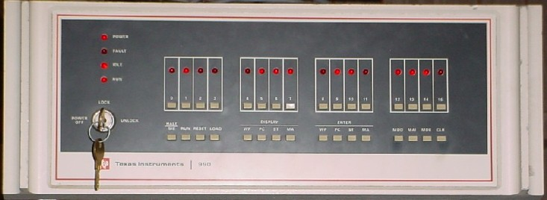

TI 990 Page
Welcome to Dave Pitts' TI 990 web page. The above picture is my Texas Instruments (TI) 990/4 system that I have at home. I worked on the TI-990 from its inception, wire wrapped boards in a TI-960 chassis, until 1979. The first 990 was the 990/9 in 1973 and was built for a large Motel chain reservation system. I worked on the cross development environment for the Motel that ran on their PDP-10 and was written in ALGOL. The 990/9 was superceeded by the 990/10 and became commercialized with memory mapping and high speed disks on the TILINE (kind of like DEC's UNIBUS). The 990/4 came out with the advent of the TMS-9900 chip in 1976. The 990/4 was superceeded by the 990/5 (added the TILINE, more memory and three on board serial ports). The 990/12 was added to the product line and added hardware floating point, writeable control store and some other "goodies". I wrote and collaborated on parts of the Operating Systems (TX990 and DX10) and various utility programs, editors, compilers, assemblers and linkers.
In seeing some of the retro-computing effort on behalf of the TI 990 I've got some links that may be of interest:
- asm990 - A Cross Assembler for the TI 990. It is written in 'C' and runs on Linux.
- lnk990 - A Cross Linker for the TI IBM 990. It is written in 'C' and runs on Linux.
- sim990 - A TI 990 simulator. It implements the TMS-9900 instructions, interrupts now work and it can boot TX990. Supported devices: Serial terminal, Serial printer, Card Reader and FD800 floppy disks. If you have any CPU diagnostics (AU04 or AU10) please send me a copy.
You will want some "disks" to run with the sim990 program:
- FORTH System - The FD800 FORTH boot image, doesn't require interrupts.
- FORTH data - The FD800 FORTH data image.

This home page is maintained by David Pitts. Please email dpitts@cozx.com with comments and corrections.
Last modified 2003/07/15.

