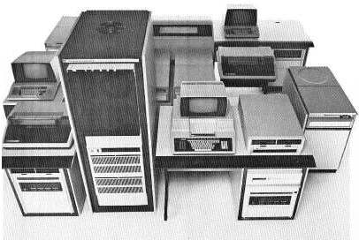
TI 990 Series Minicomputer
• 990/4 CPU 990/4 boot rom disassembly
• 990/10 CPU 990/10 universal boot rom disassembly 990/10 boot rom disassembly
• 990/10A CPU
• 990/12 CPU 990/12 boot rom disassembly

• DS990 Model 4 (DS10 disc), 6 (DS25 disc), 8 (DS50 disc)
• Business System 300, 600, 800

While on the road picking up Varian 620 parts, I bought
a 990 minicomputer, built around 1981.
This machine seems to be just below the web event horizon,
with about as much info available as the
other 'oddball' minicomputers that I have.
What I have been able to find out was TI sold their S1500 Unix workstation
product to HP (the 9000/1500) in 1992.
HP's support for 9000/1500's was dropped about 5 years ago.
The 900 series machines were not sold to HP, and no further development
was done by TI.
990s were targeted as multi-user business systems, and either ran
the DX10 or DNOS operating systems.
A company called TexX built a card called the BS100, which would run DX10
on a PC
DNOS (Distributed Network Operating System) was developed from DX10 to
support larger configurations and Networks.
DX10 ran faster on small systems, DNOS was much bulkier and so should
only be run on 990/12 CPUs with larger amounts of memory. DNOS was also
able to use the Writable Control Store (Microcode) this was used to speed
up the some operations. The final release of DNOS was 1.3.0
990 systems are still in use running various applications (primarily written
in COBOL)
A company called "Texas Computer Center" is still offering software support
for these systems.

Here are a few places on the Web that may have 990 related items
Texas Computer Center
Trident Computer (960, 980, and 990 boards and service)
Here is a pointer to a TI S1500 page in Germany
Preferred Computer in Houston (800-225-1923 x848) still repairs 990 boards

30 Oct, 1999

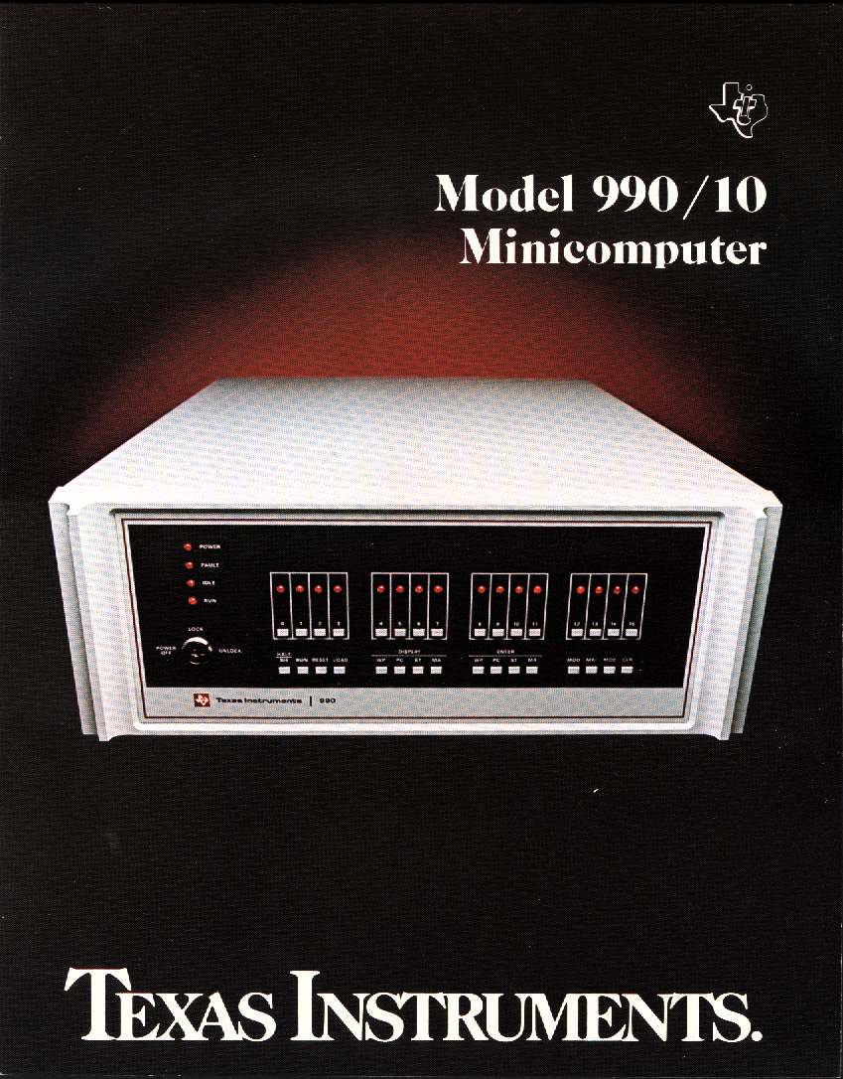
I found a book published by TI called
Microprocessors / Microcomputers / System Design
(c)1980 ISBN 0-07-063758-X
Which is a description of the 9900 family. The 990 is mentioned
as the high-end minicomputer member of the family.
990 Systems Mentioned:
• CS990/4 - 990/4 minicomputer (9900 CPU), term, floppy. $12,000 (cassette?)
• FS990/10 - 990/10 minicomputer (TTL CPU), term, floppy. $15,000
• DS990/10 - 990/10 minicomputer (TTL CPU), term, 9.4Mb disc. $25,000

Product Glossies
• DX10 Operating System

1983 TI Users Group Handouts
• Hardware Concepts The Business System 300 Architecture The TI 990/10A
• System Performace & Analysis
• p-System

PC Board Numbers

Here is a list of the PC board assembly numbers
Please email me if you have additions/corrections
96214-940065 | DSK DS25/50 CTLR
96214-2261690 | TFDC
944930 | AU (990/10)
944950 | SMI/M (990/10)
945075 | EIA
945145 | 16TTL
946076 | Dual 911 ctl
946105 | COMM
948955 | MEM (990/10)
2213060 | Encoder/Decoder
2213065 | Tape Control
2215705 | Power Board
2215826 | Processor
2218030 | HS Digitial
2218033 | PIBUS Interface
2218090 | HS Digitial
2230350 | 4 Chan Async (CI403)
2230360 | 4 Chan Async (CI404)
2231546 | Processor
2244780 | WD900 WD/MT Ctlr
2245200 | Disk IF
2261630 | Tape Ctlr 800
2261635 | Tape Ctrl 800/1600
2261980 | MEMC (990/10)
2261990 | 990/10 Cache Ctlr
2262035 | MEMA
2262100 | DSK
2269405 | ECDSK
2270820 | TPBI
2275975 | 990/10A CPU
2303085 | X.21 BCAIM
2303105 | 2 Chan Async
2308170 | MT1600
2309085 | Prog Intr Kit
2309155 | Intr CRU Buffer
2309320 | 990/12 AU
2309325 | 990/12 SMI
2309335 | 990/12 Cache Ctl
2310380 | Interrupt Module
2310945 | Printronix LPT Ctl
2310970 | EACUI
2311145 | DS80/300 Ctlr

Manuals

Here is a list of the manuals that I know about.
The manuals that I've been able to find are in bold type.
Scanned PDF files are linked to the part numbers
939152-9701 | Model 990 Computer DX10 Operating System Installation Guide
939153-9701 | DX10 Operating System Release 3.4, System Design Document
939417-9701 | Model 990 Computer DX10 Operating System Release 3 Programmer's Card
939430-9701 | Model 990 Computer FORTRAN Installation Guide
939431-9701 | Model 990 Computer COBOL Installation Guide
939432-9701 | Model 990 Sort/Merge Installation for DX10 Release 3
939460-9701 | Model 990 Computer Model 810 Printer Installation and Operation | 15 May 1979 Rev A
939524-9701 | Model 990 Computer Report Program Generator (RPG II) Programmer's Guide
943423-9701 | Model 990 Computer Model 911 Video Display Terminal Installation and Operation
943440-9701 | Model 990 Computer Programming Card
943441-9701 | Model 990 Computer TMS9900 Microprocessor Assembly Language Programmer's Guide | Rev. 1 Jan,1976
943441-9701 | Model 990 Computer TMS 9900 Microprocessor Assembly Language Programmer's Guide | 15 Dec 1979
943457-9701 | Model 990 Computer Model 913 CRT Display Terminal Installation and Operation
945250-9701 | 990 Computer Family Systems Handbook | 3rd Ed. May 1976
945236-9701 | Model 990 Computer Communications System Software
945251-9701 | Model 990/4 Computer System Hardware Reference Manual
945253-9701 | Model 990 Computer Model FD800 Floppy Disc System Installation and Operation
945254-9701 | 990-733 ASR System Software Users Manual
945258-9701 | Model 990 Computer PROM Programming Module Installation and Operation
945259-9701 | Model 990 Computer Model 733 ASR/KSR Data Terminal Installation and Operation
945260-9701 | Model 990 Computer Moving Head Disc System Installation and Operation
945261-9701 | Model 990 Computer Model 306 and 588 Line Printers Installation and Operation
945262-9701 | Model 990 Computer Model 804 Card Reader Installation and Operation
945400-9701 | Model 990 Computer Diagnostics Handbook Volume 1
945400-9702 | Model 990 Computer Diagnostics Handbook Volume 2
945400-9703 | Model 990 Computer Diagnostics Handbook Volume 3
945400-9704 | Model 990 Computer Diagnostics Handbook Volume 4
945400-9705 | Model 990 Computer Diagnostics Handbook Volume 5
945400-9706 | Model 990 Computer Diagnostics Handbook Volume 6
945400-9707 | Model 990 Computer Diagnostics Handbook Volume 7
945401-9701 | Model 990/4 Computer System Field Maintenance Manual | 1 Apr 1979
945402-9701 | Model 990/10 Computer System Field Maintenance Manual
945403-9701 | Model 990/4 Computer System Depot Maintenance Manual | 15 May 1977
945404-9701 | Model 990/10 Computer System Depot Maintenance Manual | >>>WANTED<<<
945405-9701 | Model 990 Computer PROM Programming Module Depot Maintenance Manual
945406-9701 | Model 990 Computer Model 913 CRT Display Terminal Depot Maintenance Manual
945407-9701 | Model 990 Computer 16 Input/Output TTL Data Module Depot Maintenance Manual
945408-9701 | Model 990 Computer TTY/EIA Interface Module Depot Maintenance Manual | >>>WANTED<<<
945409-9701 | Model 990 Computer Communications Systems Installation and Operation
945410-9701 | Model 990 Computer Synchronous Modem System Depot Maintenance Manual
945411-9701 | Model 990 Computer FORTRAN Programmer's Guide
945412-9701 | Model 990 Computer COBOL Programmer's Guide
945413-9701 | Model 990 Computer BASIC Programmer's Guide
945414-9701 | Model 990 Computer Models DS31 and DS32 Disc Controller Depot Maintenance Manual
945415-9701 | Model 990 Computer 16 Input/Output EIA Data Module Depot Maintenance Manual
945416-9701 | Model 990 Computer TX990 Operating System Programmer's Guide
945417-9701 | Model 990/10 Computer System Hardware Reference Manual | 15 November 1979 Rev A
945417-9701 | Model 990/10 Computer System Hardware Reference Manual | 15 November 1980 Rev B
945418-9701 | Model 990 Computer Floppy Disc Depot Maintenance Manual
945419-9701 | Model 990 Computer Peripheral Equipment Field Maintenance Guide
945419-9706 | Model CD1400 Disk System Field Maintenance Manual
945421-9701 | Model 990 Computer Family Maintenance Drawings | >>>WANTED!<<<
945421-9702 | Processors and Memories Vol. II Maintenance Drawings | >>>WANTED!<<<
945423-9701 | Model 911 Video Display Terminal Installation and Operation | Rev. 15 Jan, 1979
945423-9701 | Model 990 Computer Model 911 Video Display Terminal Installation and Operation | 15 October 1981 Rev B
945411-9701 | Model 990 Computer FORTRAN Programmer's Guide
946229-9701 | Model 979A Magnetic Tape System Installation and Operation
946231-9701 | Model DS25/DS50 Disk System Installation and Operation
946236-9701 | Model 990 Computer Communications System Software
946250-9701 | DX10 Operating System Concepts and Facilities Manual, Volume I | Rev B Apr 15, 1981
946250-9702 | DX10 Operating System Production Operation Manual, Volume II
946250-9703 | DX10 Operating System Application Programming Guide, Volume III
946250-9704 | DX10 Operating System Developmental Operation Manual, Volume IV | Rev A Dec 15, 1979
946250-9705 | DX10 Operating System Systems Programming Guide, Volume V
946250-9705G | DX10 Operating System Systems Programming Guide, Volume V | Jan, 1985
946250-9706 | DX10 Operating System Error Reporting and Recovery Manual, Volume VI
946251-9701 | Model 990 Computer BASIC Programmer's Guide
946252-9701 | Model 990 Sort/Merge User's Guide
946258-9701 | Model 990 Computer Terminal Executive Development System (TXDS) Programmer's Guide
946259-9701 | Model 990 Computer TX990 Operating System Programmers Guide ( Release 2) | Original issue 1 April 1977
946260-9701 | Model 990 Computer FORTRAN Programmer's Reference Manual
946261-9701 | Model 990 Computer Model DS10 Cartridge Disk System Installation and Operation | 15 August 1980 Rev A
946266-9701 | DX10 Operating System - Release 3 COBOL Programmer's Guide
946284-9701 | Model 990 Computer DS990 System Installation and Operation Manual | 1 April 1979
946284-9701 | DS990 Models 4, 6, and 8, Systems Installation and Operation Manual | 15 September 1980 Rev A
946289-9701 | Model 990 Computer DX2780/2780 Emulator User's Guide
946290-9701 | Model 990 Computer TI Pascal User's Manual
946294-9701 | Model 990/5 Computer Hardware User's Manual
949612-9701 | Model 979A Tape Transport Installation and Operation
949617-9701 | Model 990 Computer Link Editor Reference Manual
984030-9701 | Model 743 KSR Data Terminal Operating Instructions
2228263-9701 | DX10 Micro User's Guide
2229228-9701 | Model 931 Video Display Terminal, General Description Rev A Dec, 1983
2229229-0001 | Model 931 Video Display Terminal Field Maintenance Manual
2229230-0001 | Model 931 Video Display Terminal Depot Maintenance Manual | >>>WANTED<<<
2230312-9701 | Four-Channel Communicaitons Kit, Installation Guide
2234366-9901 | DNOS Release and Update Information
2234375-9701 | DNOS COBOL Program Generator User's Guide
2234391-9701 | TIFORM Reference Manual
2234392-9701 | EI990 Installation and Operation | Dec 1985
2234393-9701 | EI990 Ethernet Interface Maintenance Manual | >>wanted<<
2234394-9701 | EI300/EI990 Ethernet Interface Programming Manual | >>wanted<<
2234398-9701 | WD900 Disc Drive / MT3200 Tape Drive General Description | Rev C Jul, 1985
2238775-9701 | Model 990A13 Chassis Maintenacnce Manual, Field Theory and Maintenance
2238776-9701 | 990 System 990A13 Chassis Depot Theory and Maintenance
2240275-9701 | Business System 300A Operator's Guide | Rev B Jul, 1985
2240276-9701 | Business System 300A System Description Manual
2246125-0001 | CDC 138 MB Drive Vol 1
2246125-0002 | CDC 138 MB Drive Vol 2
2246125-0003 | CDC 138 MB Drive Vol 3
2246125-0004 | CDC 425 MB Drive Vol 1
2246125-0005 | CDC 425 MB Drive Vol 2
2246125-0006 | CDC 425 MB Drive Vol 3
2246126-0001 | Cipher Data Products Operation and Maintanance
2246126-0002 | Cipher Data Products Theory of Operation
2246127-0001 | Spectra Logic, Spectra 126 Product Reference | >>>WANTED<<<
2246127-0002 | Spectra Logic, Spectra 126 Schematics | >>>WANTED<<<
2246127-0003 | Spectra Logic, Spectra 126 Microcode | >>>WANTED<<<
2246129-0001 | CDC 138 MB Documentation Master Kit
2246129-0002 | CDC 425 MB Documentation Master Kit
2246130-0001 | Cipher Data Products Master Kit
2246131-0001 | Spectra Logic Documentation Master Kit
2246134-9701 | WD900/MT3200 General Description Manual
2250077-9701 | Model 990 Addendum to the TMS 9900 Microprocessor, Asm Lang Programmers's Guide for the Model 990/12 Computer
2250304-9701 | Model 990 Computer TI 990 BASIC Reference Manual
2250356-9701 | Model 990 Computer DX10 Remote Terminal Subsystem (RTS) for Model 915 Remote Terminal Installation and Operation Manual
2250361-9701 | DS990 Models 4 Through 9 Systems Site Preparation | 1 May 1981 Rev C
2250374-9701 | Model 990 Computer TIFORM User's Guide
2250425-9701 | Model 990 Computer Data Base Management System Programmer's Guide
2250426-9701 | Model 990 Computer Data Base Administrator User's Guide
2250466-9701 | Query-990 User's Guide
2250697-9701 | Model 990 Computer Model FD800 Floppy Disk System with International Chassis Installation and Operation
2250698-9701 | Model 990 Computer Model FD1000 Flexible Disk System with International Chassis Installation and Operation
2250918-9701 | DX10 3780/2780 Emulator Object Installation Manual
2250924-0001 | DX10/DS990 Operating System Release 3 (Object) Product Doc Pkg 1978
2250954-9701 | Model 990/10 DX10/3270 Information Display System Emulator Operator's Manual
2250967-9901 | Release Information, DX10/DS990 Operating System Rel 3.2-990
2261885-9702 | Model 990 Computer Model FD1000 Flexible Disk System Depot Maint Vol II | 15 Jan 1981
2262325-9701 | DS990 Model 1 Site Preparation and Installation
2263354-9701 | TIBOL Programmer's Guide
2263895-9701 | Two-Channel Asynchronous Communications Interfaces (CI402) | 15 Dec 1982
2263897-9701 | Four-Channel Asynchronous Communications Interfaces (CI403 and CI404)
2263898-9701 | Four-Channel Asynchronous Communications Interfaces (CI403 and CI404) Mantenance Manual
2264446-9701 | Model 990/12 Computer Hardware User's Guide
2268237-0001 | 990/12 Computer Manual Kit
2268239-9701 | Model 990/12 Computer Maintenance Manual, General Description
2268240-9701 | Model 990/12 Field Technical Manual
2268241-9701 | Model 990/12 Computer Depot Theory and Maintenance | >>>WANTED<<<
2268678-9701 | DS990 Systems Field Engineering Reference Handbook
2268680-9701 | DNOS FORTRAN-78 Programmer's Guide
2268681-9701 | FORTRAN-78 Reference Manual
2268687-9701 | MATHSTAT-78 Programmer's Reference Manual
2268688-9701 | Model 990 Computer TILINE Coupler User's Guide
2268696-9701 | FORTRAN-78 ISA Extensions Manual
2268698-9701 | DS990 Models 4,6, and 8 Systems Unpacking and Inventory Guide
2270500-9701 | DNOS Master Index to Operating Systems Manuals
2270501-9701 | DNOS Concepts and Facilities
2270502-9701 | DNOS Operations Guide
2270503-9701 | DNOS System Command Interpreter (SCI) Reference Manual Mar 1985
2270504-9701 | DNOS Text Editor Reference Manual
2270505-9701 | DNOS Reference Handbook
2270506-9701 | DNOS Messages and Codes Reference Manual
2270507-9701 | DNOS Supervisor Call (SVC) Reference Manual
2270508-9701 | DNOS Assembly Language Programmer's Guide
2270509-9701 | 990/99000 Assembly Language Reference Manual Nov, 1982
2270509-9701 | Model 990 Computer System 990/10 and /12 Assembly Language Reference Manual
2270510-9701 | DNOS Systems Programmer's Guide
2270511-9701 | DNOS System Generation Reference Manual
2270512-9701B | DNOS System Design Document Nov, 1983
2270513-9701 | DNOS SCI and Utilities Design Document
2270514-9701C | DNOS Object Installation Nov, 1983 (Ver 1.2.0)
2270514-9701D | DNOS Object Installation Mar, 1985
2270515-9701 | DNOS Source Installation Guide
2270516-9701 | DNOS COBOL Programmer's Guide
2270518-9701 | COBOL Reference Manual
2270519-9701 | TI Pascal Reference Manual
2270520-9701 | DNOS 3780/2780 Emulator User's Guide
2270522-9701 | DNOS Link Editor Reference Manual
2270533-9701 | DS990 Models 4 through 30 Systems Operator's Service Guide
2270534-9701 | Model 990 Computer Universal ROM Loader User's Guide 15 April 1980
2270534-9701 | ROM Loader User's Guide Rev B August, 1984
2272034-9701 | Model 990 Computer DX10 Remote Terminal Subsystem (RTS) System Generation and Programmer's Reference Manual
2272053-9701 | Model 990 Remote Terminal Subsystem (RTS) Hardware Installation Manual
2272058-9701 | DNOS Data Base Management System Programmer's Guide
2272059-9701 | DNOS Data Base Administrator User's Guide
2272060-9701 | DNOS Sort/Merge User's Guide
2272055-9701 | Model 990 Computer DX10 Remote Terminal Subsystem (RTS) Operator's Guide
2272064-9701 | DX10 Operating System Reference Card
2272075-9701 | 990 CRU/TILINE Expansion Maintenance Manual, General Description
2272109-9701 | DNOS Performance Package Documentation
2276554-9701 | DNOS Query-990 User's Guide
2276579-9701 | 990 Family Communications Systems Field Reference Manual
2276582-9701 | Data Dictionary User's Guide
2302629-9701 | Model DS80 Disk System Installation and Operation
2302631-9701 | Model DS300 Disk System Installation and Operation
2302633-9701 | Model 990/10A Computer Maintenance Manual, General Descripton Feb, 1984
2302634-9701 | Model 990/10A Computer Maintenance Manual - Field Theory and Maintenance
2302635-9701 | Model 990/10A Computer Maintenance Manual - Depot Theory and Maintenance | >>>WANTED<<<
2302640-9701 | DNOS DNCS X.25 Remote File Transfer (RFT) User's Guide
2302642-9701 | Model MT1600 Magnetic Tape System Installation and Operation
2302648-9701 | DNOS DNCS System Generaton Reference Manual
2302662-9701 | DNOS DNCS Operations Guide
2302663-9701 | DNOS DNCS/SNA User's Guide
2302664-9701 | DNOS DNCS Operations Guide
2302670-9701 | DNOS 3270 Interactive Communications Software (ICS) User's Guide
2302676-9701 | DNOS Remote Terminal Subsystem (RTS) User's Guide
2302683-9701 | DX10 3780/2780 Emulator, Release 4, User's Guide
2302688-9701 | Model 990 Computer WD800 Mass Storage System Installation and Operation Manual
2305790-9701 | TI BASIC, A Tutorial Approach to Programming
2306140-9701 | WD800/WD800A Mass Storage System Installation and Operation
2306142-9701 | WD800/WD800A Mass Storage System Field Maintanance Manual
2308769-9701 | TI BASIC Reference Manual
2308772-0001 | Model 990A Chassis Manual Kit
2308774-9701 | Model 990A13 Chassis General Description
2308777-0001 | 990 Memory Manual Kit
2308779-9701 | Model 990 Computer Memory General Description
2308780-9701 | Model 990 Computer Memory Field Technical Manual
2308781-9701 | Model 990 Computer Memory, Depot Theory and Maintenance | >>>WANTED<<<
2308783-9701 | DNOS Common Communications Utilities
2308789-9701 | 990A13 Programmer Panel, Operation and Maintenance Manual
2308793-9701 | DNOS Distributed Network I/O (DNIO) User's Guide
2308868-9701 | DNOS TIPE Reference Manual Kit
2308868-9701 | DNOS TIPE Exercise Guide Kit
2308954-9701 | DNOS Security Manager's Guide
2308789-9701 | Model 990A13 Programmers Panel, Operation and Maintenance
2311340-9701 | Business Systems 600/800 Site Preparation Manual
2311341-9701 | Business Systems 600/800 Installation Manual
2311342-9701 | Business Systems 600/800 Unpacking and Inventory Guide
2311343-9701 | Business Systems 600/800 Operator's Guide
2311344-9701 | Business Systems 600/800 Field Engineering Reference Handbook
2311345-9701 | Business Systems 600/800 Field Maintenance Manual
2533262-9701 | DX10 Micro Operating System Handbook
2533266-9701 | Business System 200 Operator's Guide
2533308-9701 | Business System 300 System Description Manual
2533313-9701 | Two-Channel Communications Kit, Installation Guide
2533318-9701 | Business System 300 Operator's Guide
2533319-9701 | Operator's Guide, WD800 Disk Unit
2533322-9701 | DX10 Micro Messages and Codes
2533269-9701 | Operator's Guide, WD500/WD500A Disk Unit
2540219-0001 | 990/SCSI Mass Storage Subsystem General Description | Rev A Sep, 1988
2540724-0001 | Model 924 VDT Maintenance Drawing
2544365-0001 | Model 924 Video Display Terminal User's Guide
2547176-0001 | 945 Workstation User's Guide
2549488-0001 | Mass Storage Unit (MSU II) General Description
2557935-0001 | Mass Storage Unit (MSU IIA) Installation and Operation | Rev B Oct, 1989

